


DEPARTMENT OF ROBOTICS & ARTIFICIAL INTELLIGENCE
Total Marks: 7.5

Obtained Marks:

Object oriented Programming LAB
Project Report

Last Date of Submission: 18th May, 2026

Submitted To: Mr. Hasaan Mujtaba

Student Name | Registration Number
Syed Azaan shah | 25108274
Sumbul Shahid | 25108273
Shaheer Naeem | 25108271



DEPARTMENT OF ROBOTICS & ARTIFICIAL INTELLIGENCE

Project title: Life Simulation Engine (Text-Based Simulator)

Introduction:
The Life Simulation Engine is a console-based application developed in C++ using Object-Oriented Programming (OOP) principles. The project simulates a virtual human life, allowing the user to control a character and make daily decisions that affect long-term outcomes. The simulation is designed to represent real-life situations in a simplified digital form.
The user progresses through multiple simulated days, each with choices such as studying, working, resting, or exercising. Every decision has direct consequences on the character’s attributes, such as health, energy, money, skill, and happiness. The system is designed to reflect how consistent daily habits shape a person’s overall life trajectory.

Project Aims:

The main aims of this project are:
- To create a realistic simulation of human life decisions in a structured environment
- To demonstrate how small daily actions can lead to significant long-term consequences
- To apply Object-Oriented Programming concepts in a meaningful and practical way
- To improve logical thinking, planning, and decision-making skills
- To develop a system that visually represents cause-and-effect relationships in life
- To build an interactive console-based project that is both educational and engaging



Implementation Process:
The implementation process begins with designing a virtual character that represents the user inside the simulation. The character is assigned initial attributes such as health, energy, money, skill, and happiness. The program then runs in a loop representing days in the simulation.
Each day, the user is presented with a set of possible actions. The user selects an action, and the system processes the decision by updating the character’s attributes. For example, studying increases skill but decreases energy, while working increases money but may reduce happiness or energy.
To make the simulation more realistic, random events are introduced. These events may positively or negatively affect the character, such as gaining an opportunity, facing illness, or receiving unexpected rewards. The simulation continues for a fixed number of days, after which final results are calculated and displayed.

Implementation and Working:

The system's operation is based on continuous user interaction and attribute management. Each user-selected action triggers specific changes in the character’s state. The system maintains updated values of all attributes every day.
For example:
- Studying improves skills but reduces energy.
- Working increases financial status but may reduce rest levels.
- Resting restores energy but does not improve other attributes.
- Exercising improves health but consumes energy.
The system follows a structured flow in which each day represents a cycle of decision-making, attribute updates, and event handling. The program also ensures that the values remain within logical limits (e.g., health and energy do not exceed maximum values or drop below zero).
At the end of the simulation, the system evaluates the user’s performance based on the final states
of all attributes and the overall balance achieved.



Framework and Attributes:

The project is built using Object-Oriented Programming in C++, where the system is divided into multiple structured modules for better organization and maintainability.

Main Modules:
- Character Module: Handles creation and management of the virtual character and its attributes
- Action Module: Defines all possible user actions and their effects on the character
- Game Engine Module: Controls the main flow of the simulation, including day progression
- Event Module: Generates random life events that affect gameplay dynamically
- Report Module: Calculates and displays final results and performance analysis

Key Attributes:
- Health: Represents the physical condition of the character
- Energy: Determines the ability to perform actions
- Money: Represents financial status
- Skill: Represents knowledge and personal development
- Happiness: Represents emotional well-being
These attributes are continuously updated based on user decisions and in-game events.

End Result:

At the end of the simulation, the system generates a complete performance report of the virtual life. This report includes the final values of all attributes, an overall evaluation of the user’s decisions, and a summary of how different choices influenced the outcome.
The end result allows users to clearly understand whether their life decisions led to a balanced, successful, or poor outcome. It also highlights strengths and weaknesses in decision-making patterns throughout the simulation.



Conclusion:
The Life Simulation Engine is an interactive, educational project that effectively demonstrates the impact of decision-making in a controlled, virtual environment. It uses Object-Oriented Programming concepts in C++ to create a structured, logical system that simulates real-world scenarios.
The project helps users understand how daily habits and choices influence long-term success and personal development. It also strengthens programming skills by applying core OOP principles such as encapsulation, modularity, and structured system design. Overall, this project serves as both a technical and conceptual learning experience.

Code:

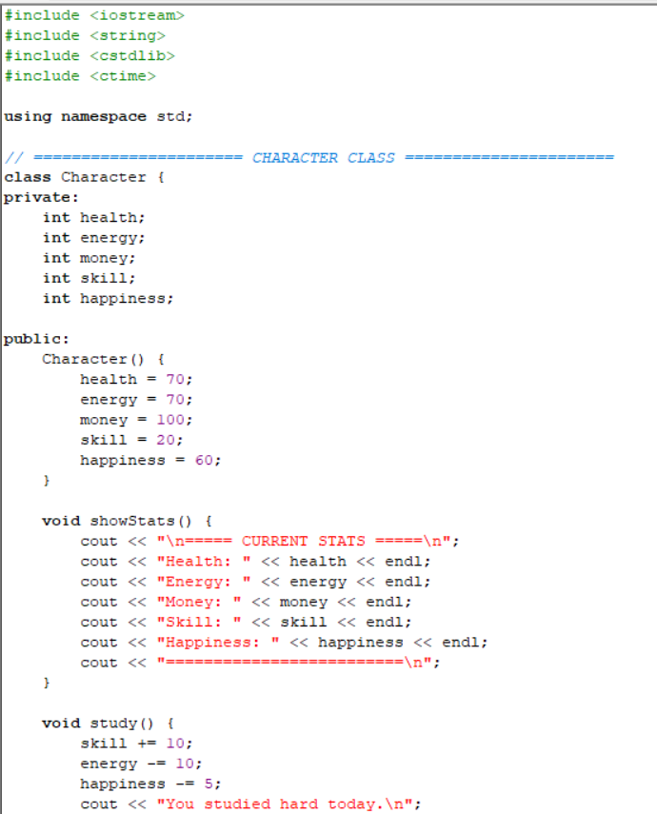

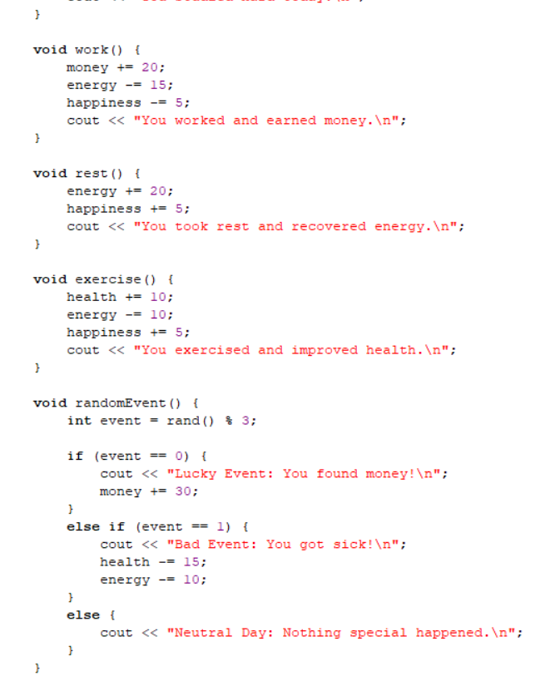
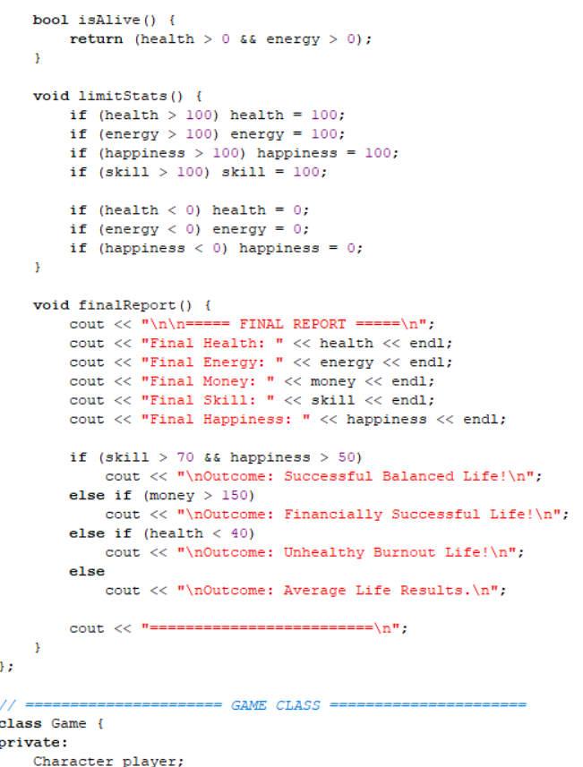

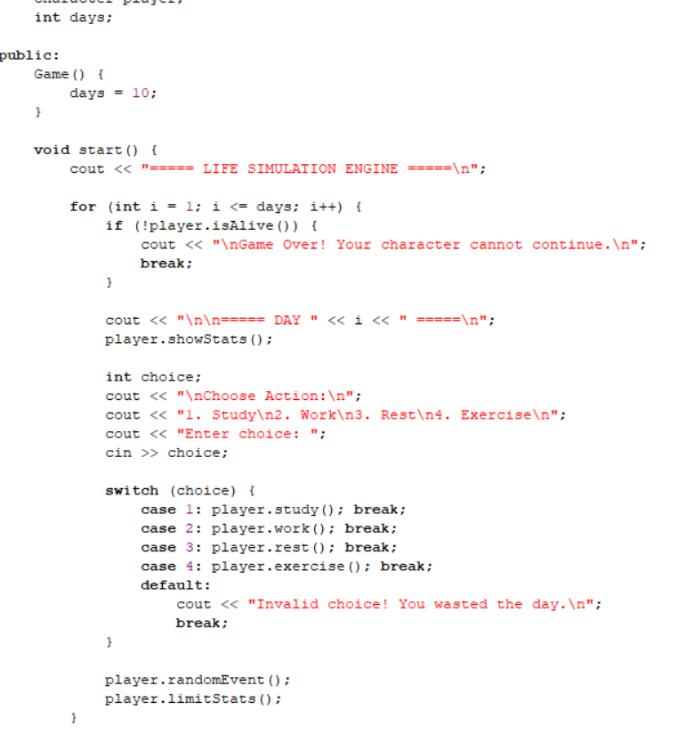
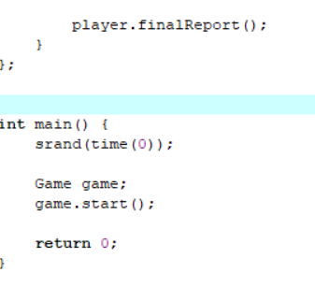

Output:

